 | 12.1.14 Editors - Geometry Nodes Editor - Header - Add Menu - Mesh Primitives
Table of content
Detailed table of content 1
Add menu - Mesh Primitives 3
Circle 3
Cone 4
Cube 4
Cylinder 5
Grid 6
Ico Sphere 6
Line 7
UV Sphere 7

Detailed table of content
Detailed table of content
Detailed table of content 1
Add menu - Mesh Primitives 3
Circle 3
Input 3
Vertices 3
Radius 3
Properties 3
Fill Type 3
None 3
N-Gon 3
Triangles 3
Outputs 3
Geometry 3
Cone 4
Input 4
Vertices 4
Radius Top 4
Radius Bottom 4
Depth 4
Properties 4
Fill Type 4
None 4
N-Gon 4
Triangles 4
Outputs 4
Geometry 4
Cube 4
Input 4
Size 4
Outputs 5
Geometry 5
Cylinder 5
Input 5
Vertices 5
Radius 5
Depth 5
Properties 5
Fill Type 5
None 5
N-Gon 5
Triangles 5
Outputs 5
Geometry 5
Grid 6
Input 6
Size 6
Vertices X 6
Vertices Y 6
Outputs 6
Geometry 6
Ico Sphere 6
Input 6
Radius 6
Subdivisions 6
Outputs 6
Geometry 6
Line 7
Input 7
Count 7
Start Location 7
Offset 7
Properties 7
Mode 7
Offset 7
End Points 7
Count Mode 7
Count 7
End Points 7
Outputs 7
Geometry 7
UV Sphere 7
Input 7
Segments 7
Rings 8
Radius 8
Outputs 8
Geometry 8

Add menu - Mesh Primitives
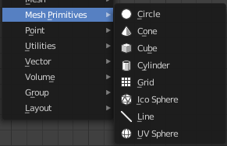
Nodes to modify the mesh geometry.

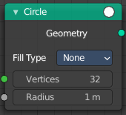
Circle
Circle creates a Circle mesh.

Input

Vertices
Number of vertices.

Radius
The initial radius.

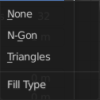
Properties

Fill Type
Defines how the Circle mesh is filled.

None
pure edge geometry.

N-Gon
The circle face is a N-Gon face.

Triangles
The circle face is triangulated.

Outputs

Geometry
Standard geometry output.

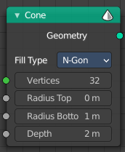
Cone
Cone creates a Cone mesh.

Input

Vertices
Number of vertices.

Radius Top
The initial radius at the top.

Radius Bottom
The initial radius at the bottom.

Depth
The initial height.

Properties

Fill Type
Defines how the Circle mesh is filled.

None
pure edge geometry.

N-Gon
The circle face is a N-Gon face.

Triangles
The circle face is triangulated.

Outputs

Geometry
Standard geometry output.

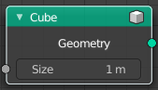
Cube
Cube creates a Cube mesh.

Input

Size
The initial size.

Outputs

Geometry
Standard geometry output.

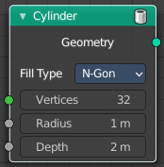
Cylinder
Cylinder creates a Cylinder mesh.

Input

Vertices
Number of vertices.

Radius
The initial radius.

Depth
The initial height.

Properties

Fill Type
Defines how the Circle mesh is filled.

None
pure edge geometry.

N-Gon
The circle face is a N-Gon face.

Triangles
The circle face is triangulated.

Outputs

Geometry
Standard geometry output.

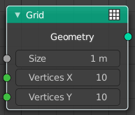
Grid
Grid creates a grid mesh.

Input

Size
The initial size.

Vertices X
The initial number of vertices in X direction.

Vertices Y
The initial number of vertices in Y direction.

Outputs

Geometry
Standard geometry output.

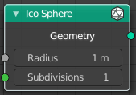
Ico Sphere
Ico Sphere creates a ico Sphere mesh.

Input

Radius
The initial radius.

Subdivisions
The initial subdivisions.

Outputs

Geometry
Standard geometry output.

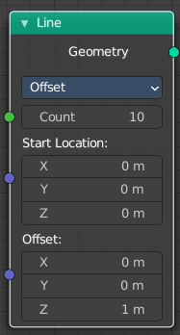
Line
Line creates a line mesh.

Input

Count
The initial number of segments.

Start Location
The initial location.

Offset
The initial offset.

Properties

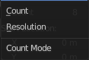
Mode

Offset
Specify the offset from one vertice to the next.

End Points
Specify the line start and endpoints.

Count Mode

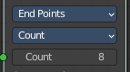
Count
Specify the number of total vertices.

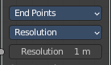
End Points
Specify the distance between the vertices.

Outputs

Geometry
Standard geometry output.

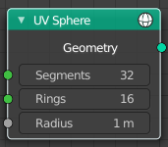
UV Sphere
UV Sphere creates a uv sphere mesh.

Input

Segments
The initial number of segments.

Rings
The initial number of edgerings.

Radius
The initial radius.

Outputs

Geometry
Standard geometry output.

